**Configuration of Basic Application in CVP Call Studio:**

**Introduction:**

Use case projects demonstrate creating basic application ( Beginner) using Call Studio Application.

**Creation of Application in Call Studio:**

**Create HelloWorld Application:**

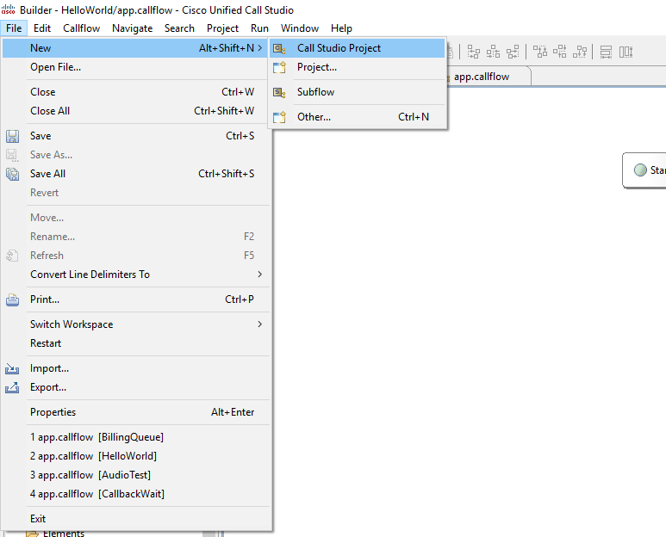

**Create a sample Call Flow:**

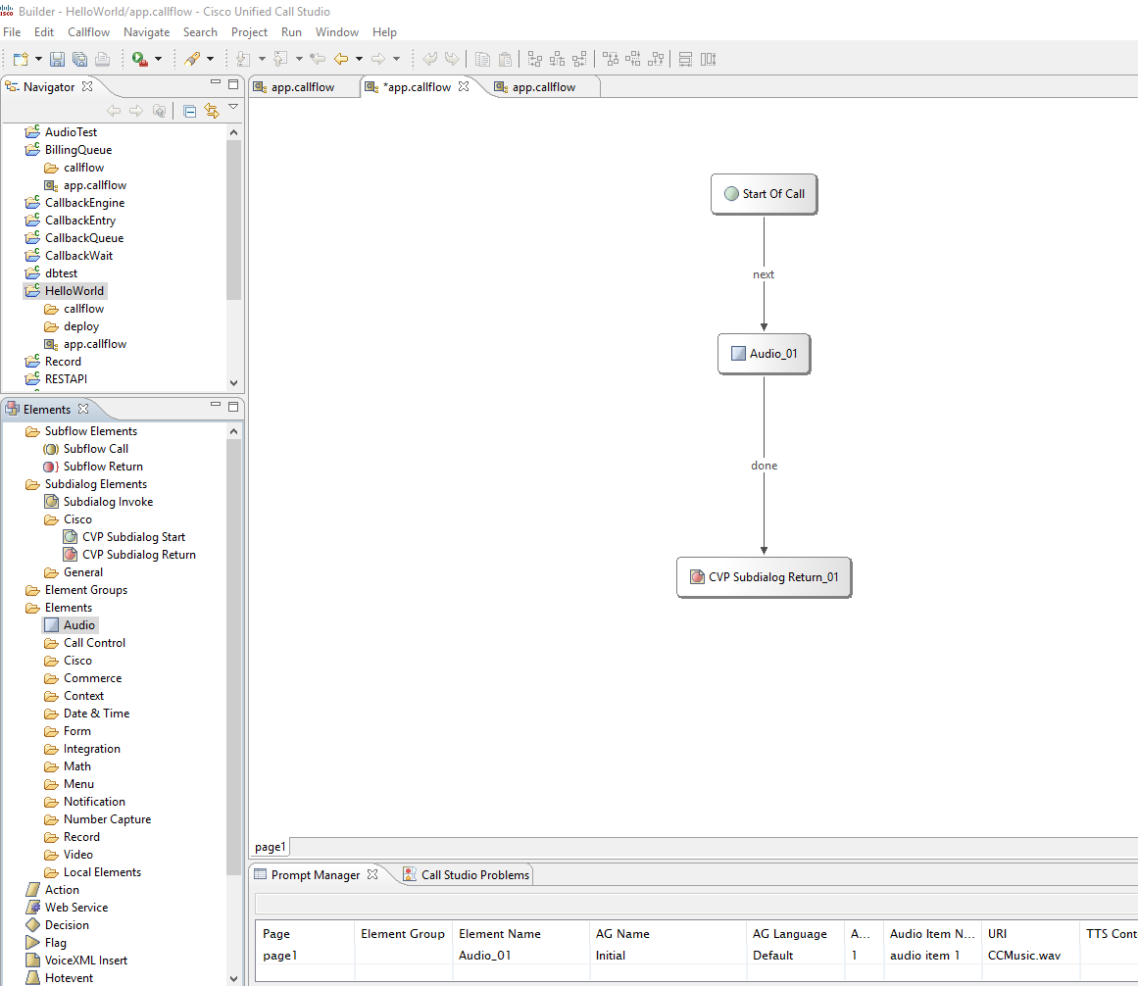

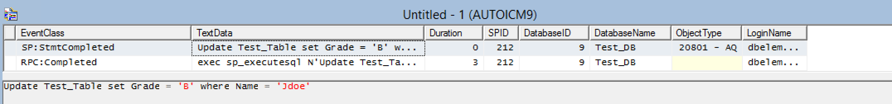

Configure Audio Element:

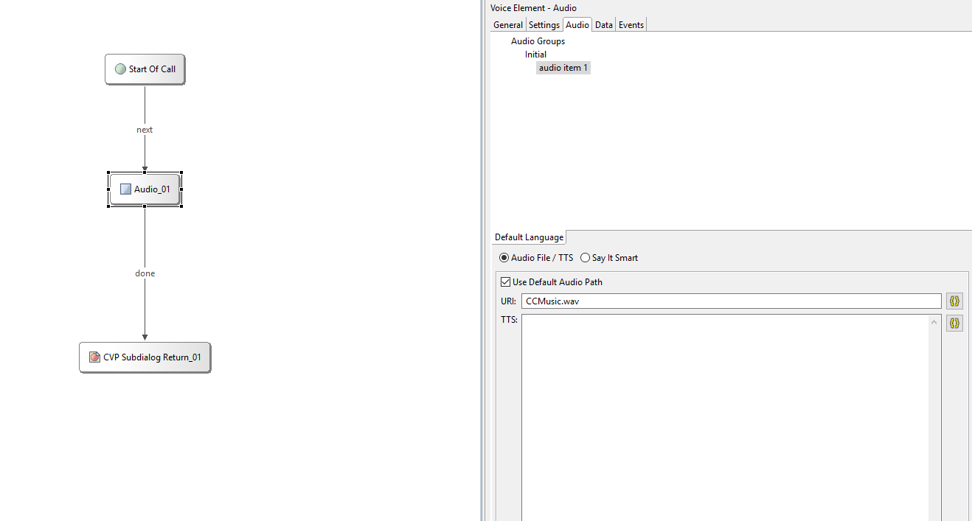

Note : Use Default Audio Path -> Music file points to

C:\Cisco\CVP\VXMLServer\Tomcat\webapps\CVP\audio

Configure SubDialog Return :

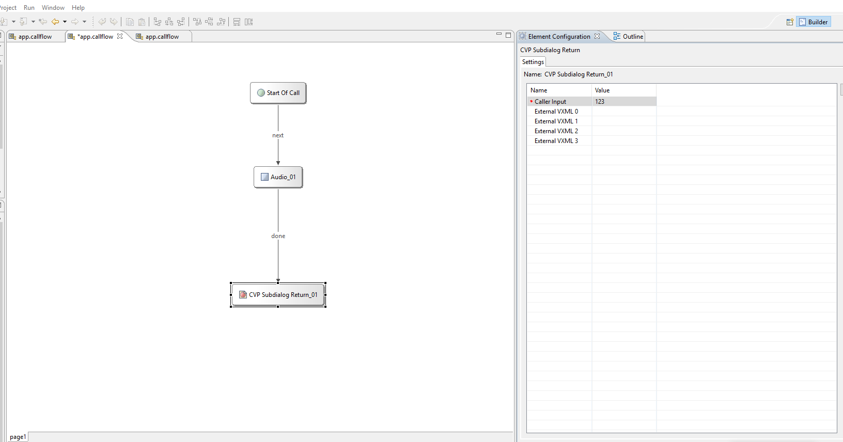

Configure Gateway Adapter and Logger:

Right Click on Project -> Call Studio -> General Settings

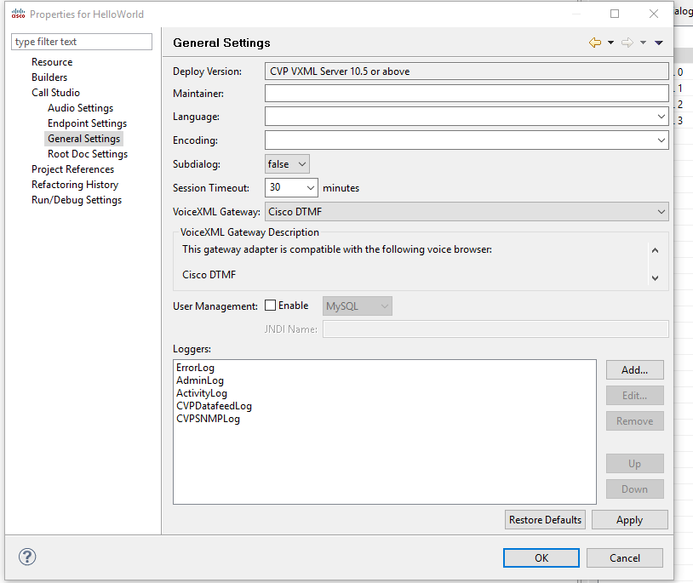

Validate Project:

Validate project for any known errors.

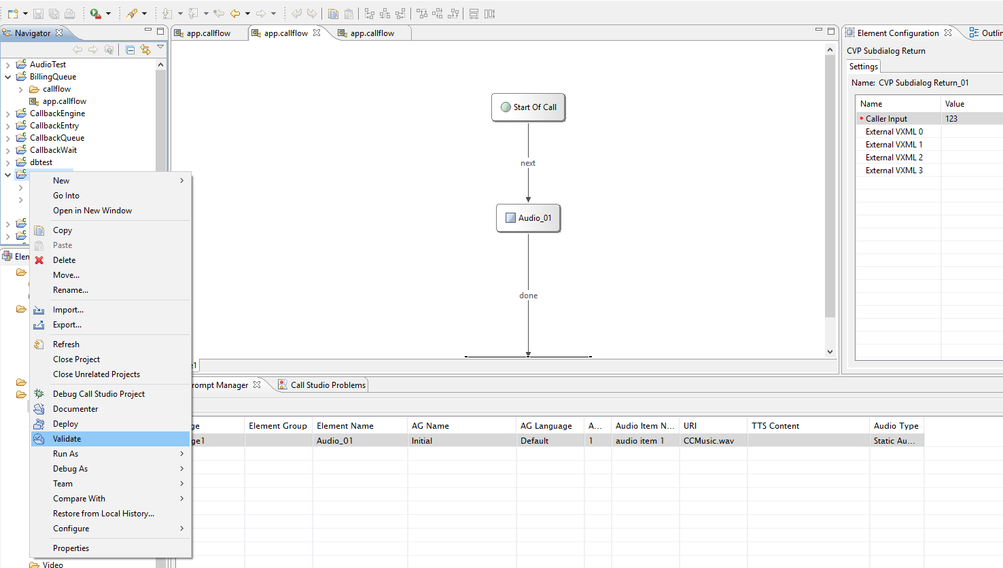

Deploy Project:

Deploy project to local system or remote

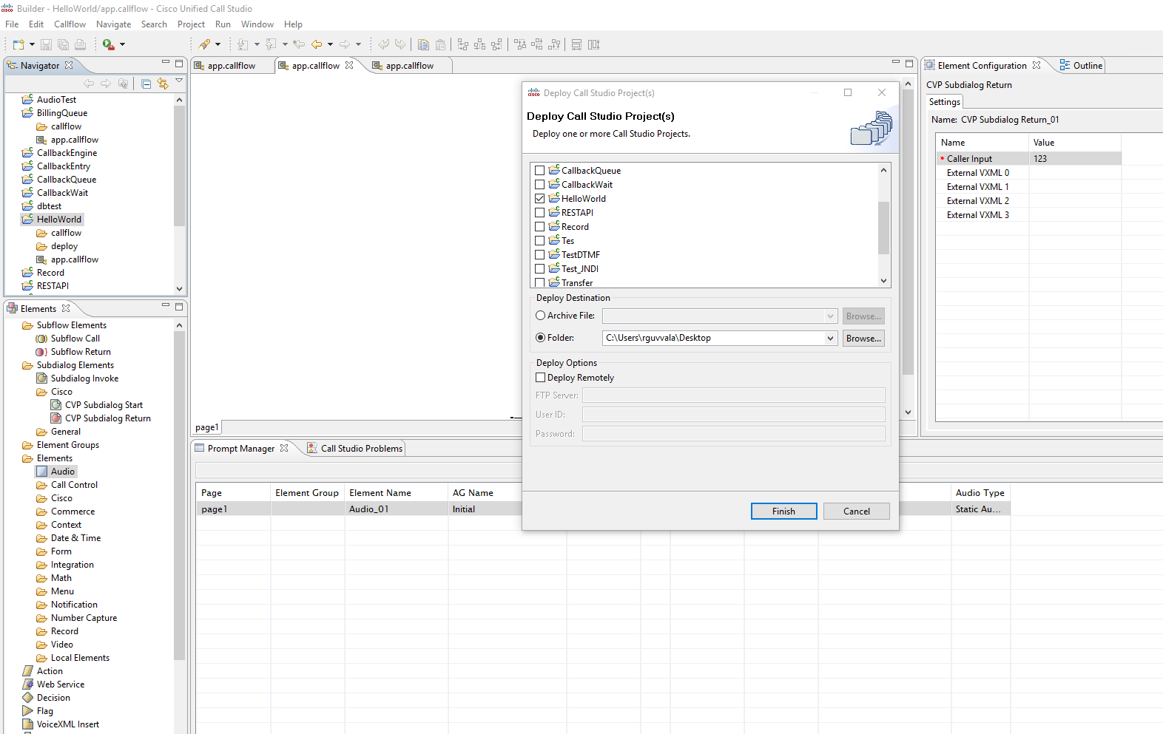

Debug Project:

* Right click on Call Studio -> Debug Call Studio
* Click on Connect

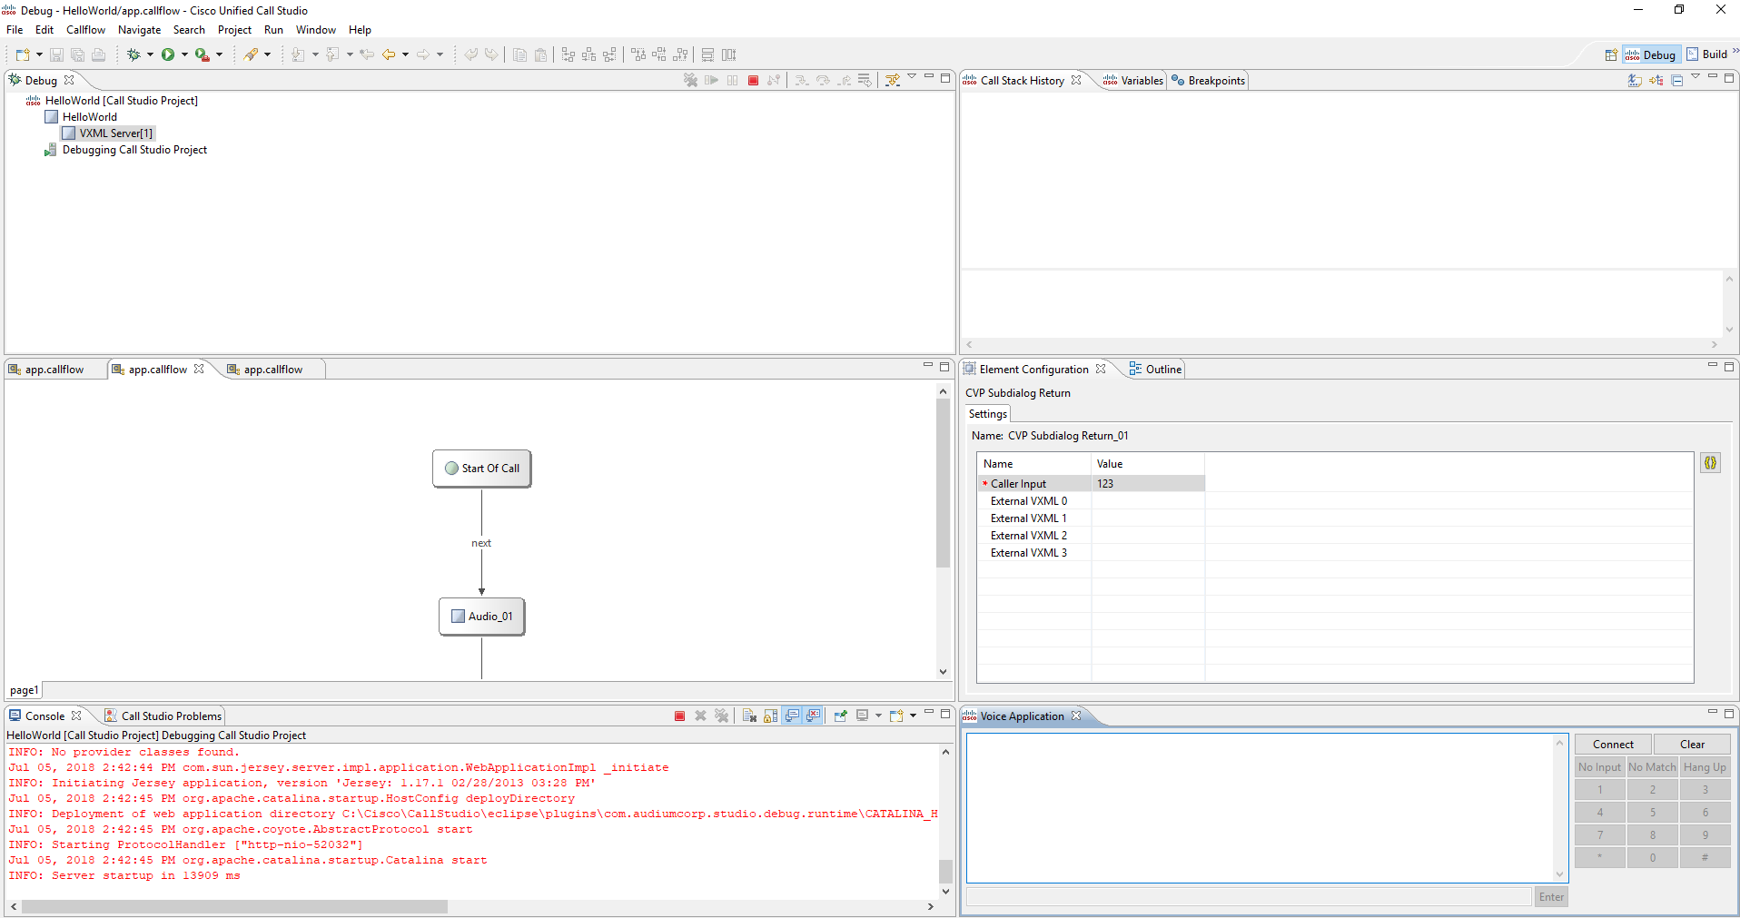

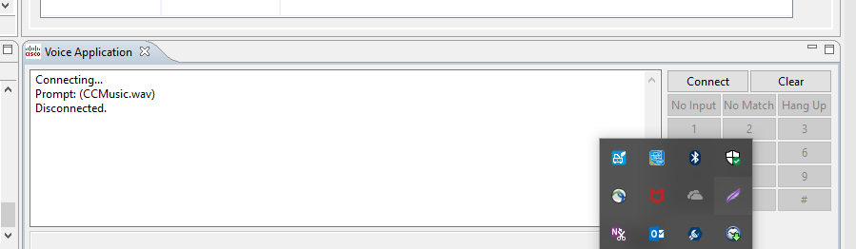

Moving from Debug Perspective to Build

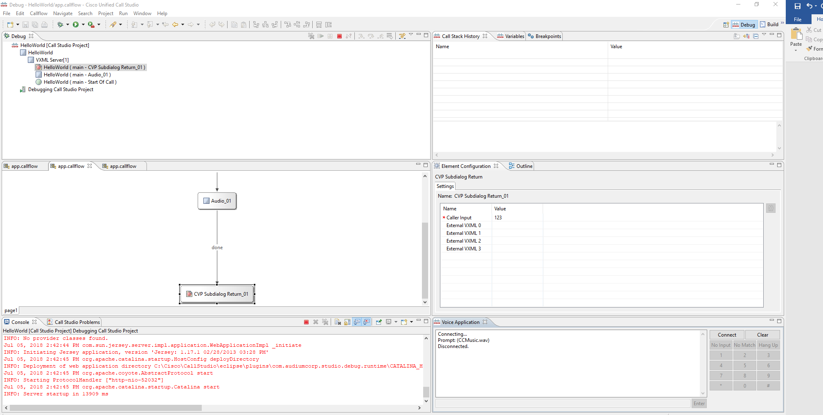

* Click on red button to stop debug perspective
* Click on build
* Logs for trouble shooting located under : *C:\Cisco\CallStudio\eclipse\plugins\com.audiumcorp.studio.debug.runtime\AUDIUM_HOME\applications\HelloWorld*

Export Project:

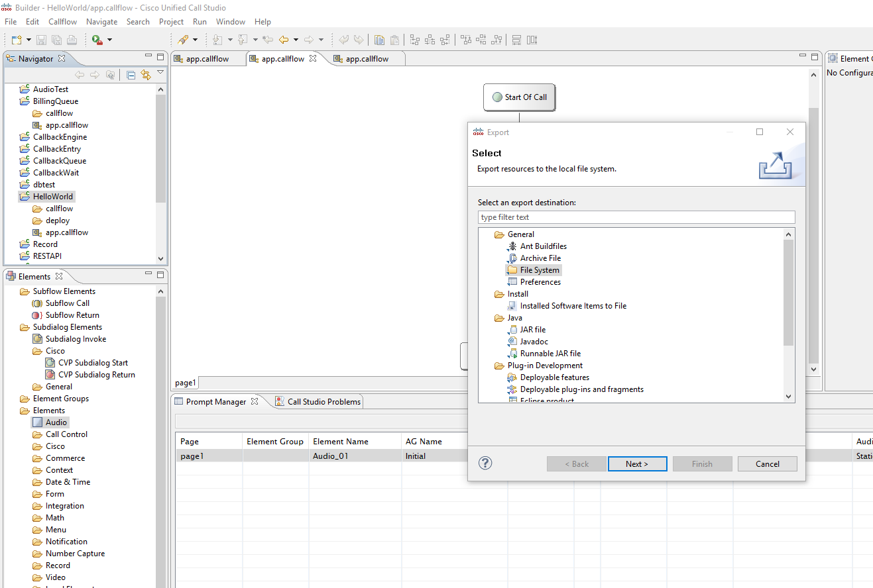

Right Click on Project -> Export -> General -> File System.

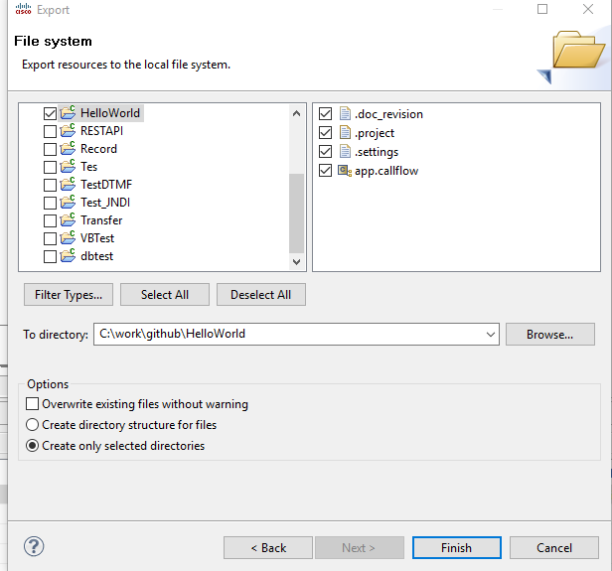

Import Project:

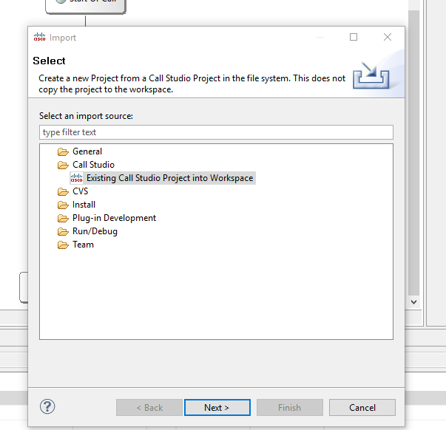

Log Analysis:

Sample Activity logs:

10.156.138.118.1530827315155.0.HelloWorld,07/05/2018 14:48:35.202,,start,newcall,

10.156.138.118.1530827315155.0.HelloWorld,07/05/2018 14:48:35.202,,start,ani,NA

10.156.138.118.1530827315155.0.HelloWorld,07/05/2018 14:48:35.202,,start,areacode,NA

10.156.138.118.1530827315155.0.HelloWorld,07/05/2018 14:48:35.202,,start,exchange,NA

10.156.138.118.1530827315155.0.HelloWorld,07/05/2018 14:48:35.202,,start,dnis,NA

10.156.138.118.1530827315155.0.HelloWorld,07/05/2018 14:48:35.202,,start,uui,NA

10.156.138.118.1530827315155.0.HelloWorld,07/05/2018 14:48:35.202,,start,iidigits,NA

10.156.138.118.1530827315155.0.HelloWorld,07/05/2018 14:48:35.207,Audio_01,enter,

10.156.138.118.1530827315155.0.HelloWorld,07/05/2018 14:48:35.222,Audio_01,interaction,audio_group,initial_audio_group

10.156.138.118.1530827315155.0.HelloWorld,07/05/2018 14:48:35.507,Audio_01,exit,done

10.156.138.118.1530827315155.0.HelloWorld,07/05/2018 14:48:35.507,CVP Subdialog Return_01,enter,

10.156.138.118.1530827315155.0.HelloWorld,07/05/2018 14:48:35.539,CVP Subdialog Return_01,exit,

10.156.138.118.1530827315155.0.HelloWorld,07/05/2018 14:48:35.542,,end,how,app_session_complete

10.156.138.118.1530827315155.0.HelloWorld,07/05/2018 14:48:35.542,,end,result,normal

10.156.138.118.1530827315155.0.HelloWorld,07/05/2018 14:48:35.542,,end,duration,0